# Project Timeline

The project timeline file can be found in the Microsoft Teams “Files” tab.

Filename: “Senior Project Gantt Chart.xlsx”

Sprint 1:

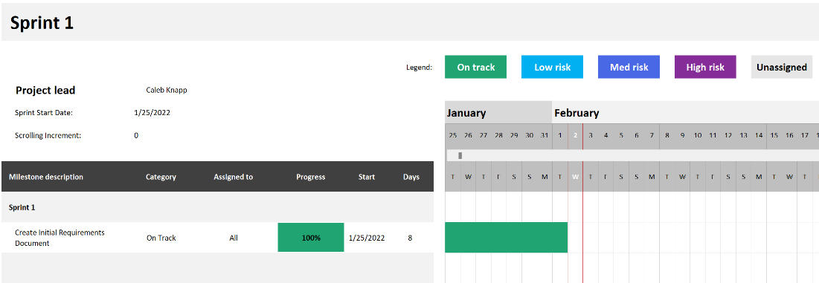

Sprint 2:

Sprint 3:

Sprint 4:

Sprint 5:

Sprint 6:

Sprint 7:

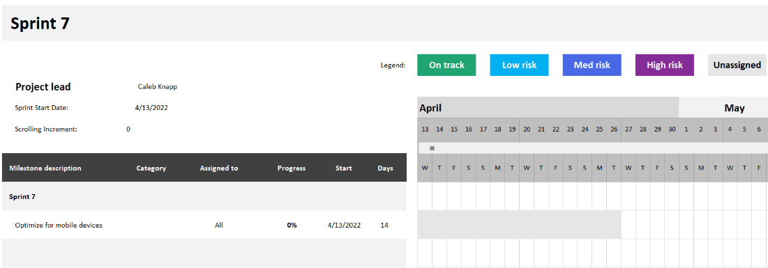

Sprint 8:

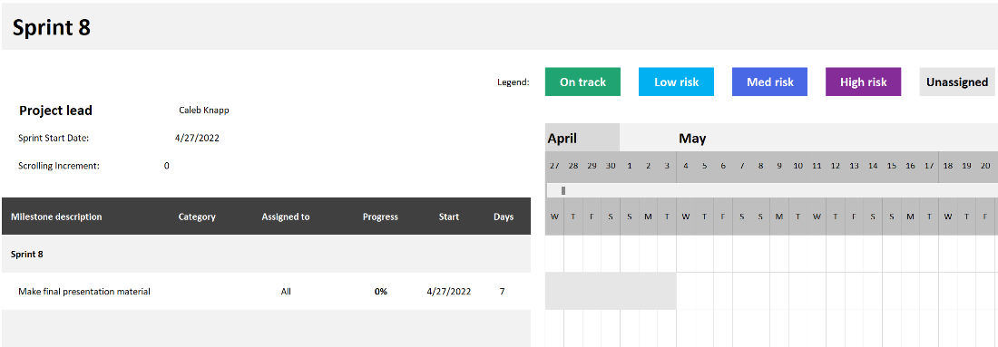

# Requirements Fulfilled

Requirements fulfilled in Sprint 6:

1. Messages can be flagged and deleted.
2. Files can be uploaded and downloaded.
3. Confirmation emails are sent on account creation.
4. Site layout fits to screen.

# Features Implemented

Program features implemented in Sprint 6:

1. File Sharing
2. Admin Chat Features

# Database Design

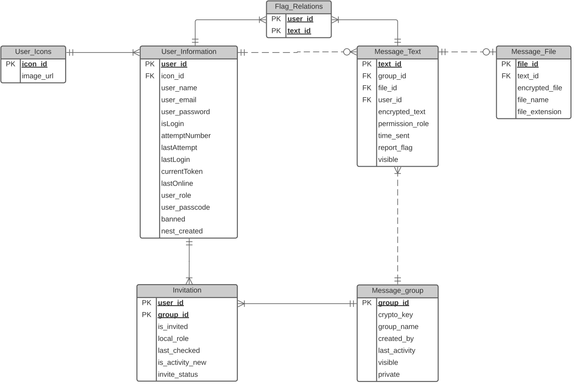

# Feature Priority List

|  |
| --- |
|  |
| 1. User Icons |
| 1. Layout Finalization |
| 1. Mobile Optimizations |

# Risk Ledger

Date of last review: 3/1/2022

|  |  |  |  |  |
| --- | --- | --- | --- | --- |
| ID | Description of Risk | Impact | Risk Response | Risk Level   (Impact vs. Probability) |
| 1 | Group Member Unavailable (sick/vacation/not in lab) | Development Time Crippled | Use of Pair Programming: Dividing up into two team members so that code use is known by more than one person | High |
| 2 | Covid Isolation | Unable to Meet Physically | Use of Teams Online Meetings to ask questions and discuss any questions along with access to almost all aspects of the project also available online. Work can be done remotely through visual studios and documents uploaded/ updated on teams or GitLab. | High |
| 3 | HTTP Security | Exposed User Data | HTTPS on Service Launch: while current development is around an http website, we would theoretically have a certificate for https for final use. | High |
| 4 | Server Capacity/ Resource Cost | Slows Down Processes | Clear Unused Resources: We currently have no issue with data transfer to and from the database, but if ever there was too much going on slowing down our systems, we would investigate clearing resources or transfer the data storage locations. We will also limit the number of messages we pull to the page to lower resource cost. | Medium |
| 5 | Shoulder Surfing | User Data Compromised | Time Out on User Messages: Use of a “lock” mechanism on messages. This would be used to grey out messages until the user clicked them to “unlock them”. | Medium |
| 6 | Incorrect User Access and Permissions | User Data Compromised | Assertion functions are in use in the database to mitigate this risk. All functions to access data on the database use assertion functions to validate a user's permissions and existence. Usernames are unique but are not used to check access. Emails are also unique and used for account recovery, not data access. Use of user IDs assigned on creation to validate user access message data and groups. | Medium |
| 7 | Password Recovery | Users Locked Out of Accounts | Use Email to Reset Password: 2FA. The one-time key is reset upon every attempt to avoid a rainbow attack to reset a user's password. | Low |
| 8 | User Account Theft (Password Recovery) | User Account Compromised | Use Email as an Authentication Method, and Use of a Maximum Number of Login Attempts to Protect from a Rainbow Table Brute Force Attacks. Resetting password uses a one-time key that will be reset at every use to avoid brute force rainbow attack. | Low |
| 9 | Encryption Method Leak | User Data Compromised | Not storing algorithms as something viewable on the page. | Low |
| 10 | Data Transfer Security | User Data Compromised | All messages are stored in the database using symmetric encryption. The key is based on the group the message is part of. | Low |
| 11 | Group Message Data Encryption | Data Security Among Users | Encryption Based on Permissions: The “lock” feature would also be used in this scenario. Users with the correct permissions would be able to “unlock” resources. | Low |
| 12 | Change in User Needs | Delays, Requirements Change | Keep Project Agile and Modular: Using an object-oriented programming style, Using organization of pages with the use of a master page, using simple yet understandable variable names, organizing classes and functions in an understandable manner. All of this will help when going back to assess old code or when adding to the code. | Low |
| 13 | Resource Availability | Delays, Development Cuts | Assess Available Resources and Relocate: We currently have no issue with data transfer to and from the database, but if ever there was too much going on slowing down our systems, we would investigate clearing resources or transfer the data storage locations. | Low |
| 14 | SQL Injection through C# Code | User Data Compromised | Use of BIND Variables in our C# code to only allow variables used in the functions to be sent to database. | Low |
| 15 | Password Security | User Account Compromised | Use Hashing for Database Storage: The User Chooses a password that is sent to the database and using the user’s password, username, and a 128-bit salt we hash the password. Then henceforth when the user logs in, we just pass a hash to compare to the hash in the database. | Low |
| 16 | Chat Profanity During Expo | Unable to Show Project | We have limited the user to only emails using pcci.edu, and we will require email confirmation for new accounts. This will be coupled with a profanity filter that should catch profanities but if they surpass it we will have their confirmed email. Use of the admin page to track flagged messages will also be implemented. | Low |

# Team Meeting Days and Times

|  |  |
| --- | --- |
| Day | Time Spent |
| 3-30-2022 | 1 hour |
| 3-31-2022 | 1 hour |
| 4-1-2022 | 1 hour |
| 4-2-2022 | 1 hour |
| 4-4-2022 | 2 hours |
| 4-6-2022 | 1 hour |
| 4-8-2022 | 1 hour |
| 4-9-2022 | 3 hours, 30 minutes |
| 4-11-2022 | 1 hour |

# Reflections

Product Owner/Shareholder: Dr. Johnathan Sparks  
Scrum Master: Caleb Knapp/Mason Philips/ Timothy De Jesus/ Himprawa Khattri  
Developers: Timothy De Jesus/ Himprawa Khattri/ Caleb Knapp/Mason Philips

Sprint review: We implemented file sharing and some chat moderation features.

1. Communication has improved greatly overall.
2. We still need to create our user manual.
3. Major functionality is finished.

# Backlog

Sprint 7

* User icons
* Optimizations for mobile devices

Sprint 8

* Make final presentation

# Next Sprint Focus

Tasks being focused on for next sprint:

1. User Icons
2. Style Finalization
3. Finish Moderation Features
4. Blocking Users

# Acceptance Tests

1. User Icons
   1. Users are assigned a random pigeon stock photo as a user icon.
   2. Users can change these in the user settings page.
   3. Icons appear in nav bar, members list, and beside messages.
2. Finish Moderation Features
   1. System admins can ban users from the site.
   2. Flag all files by default.
3. Blocking Users
   1. Users can block other users.
      1. Users can’t see messages from others who have blocked them, and users won’t see messages from others they have blocked either.
      2. Blocked users can not private message each other.